Game analyses

Q1) Extract P_ID,Dev_ID,PName and Difficulty_level of all players

-- at level 0

Ans:

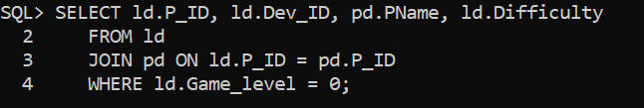

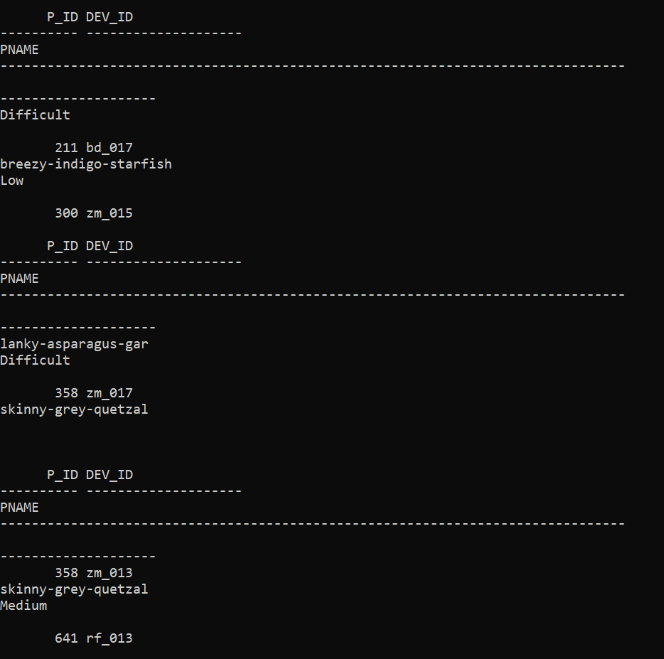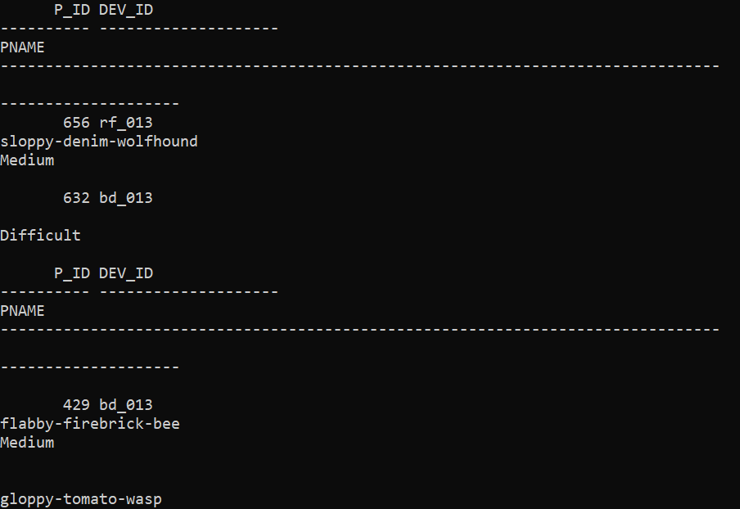

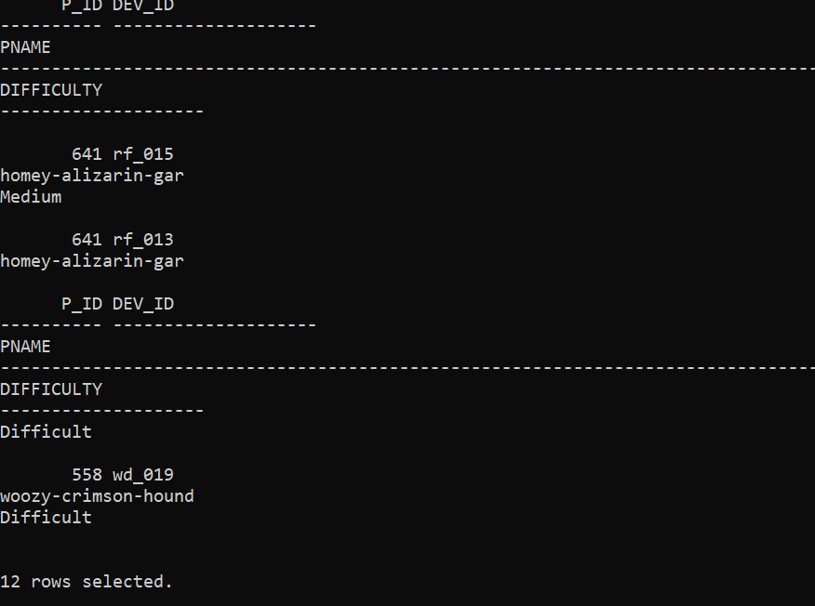

Q2) Find Level1_code wise Avg_Kill_Count where lives_earned is 2 and atleast--3 stages are crossed

Ans:

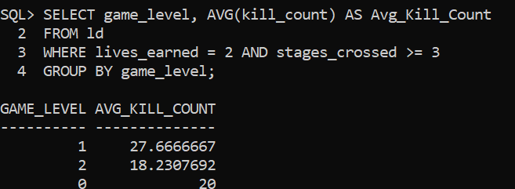

Q3) Find the total number of stages crossed at each diffuculty levelwhere for Level2 with players use zm_series devices. Arrange the result in decsreasing order of total number of stages crossed.

Ans:

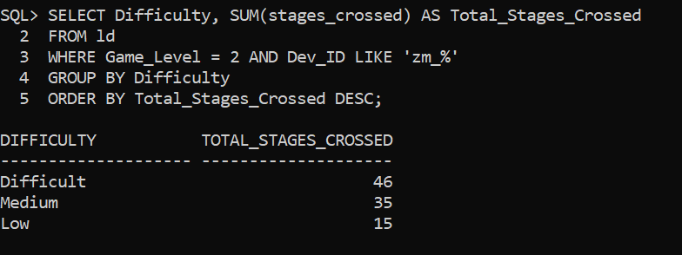

Q4) Extract P_ID and the total number of unique dates for those players who have played games on multiple days.

Ans:

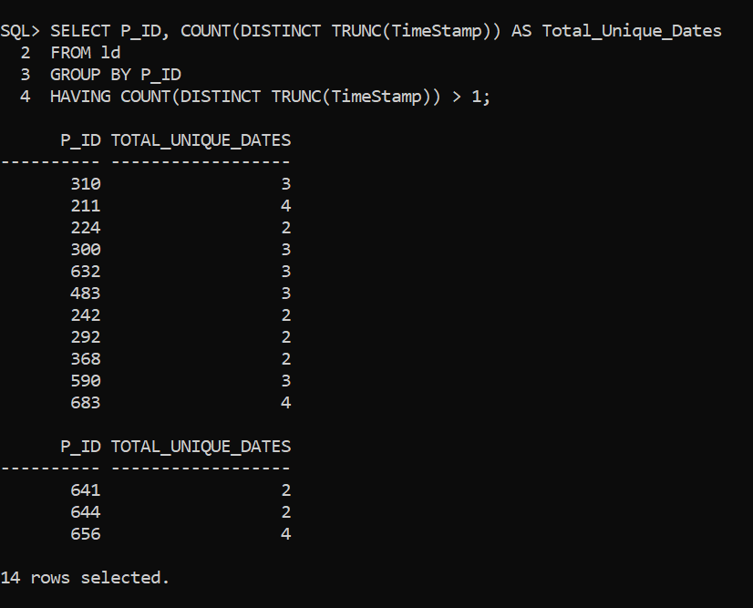

Q5) Find P_ID and level wise sum of kill_counts where kill_count is greater than avg kill count for the Medium difficulty.

Ans:

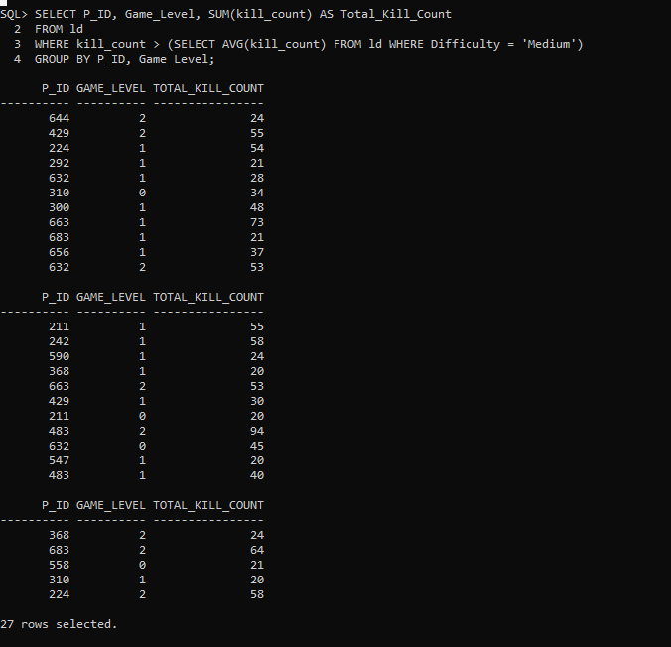

Q6) Find Level and its corresponding Level code wise sum of lives earned excluding level 0. Arrange in asecending order of level.

Ans:

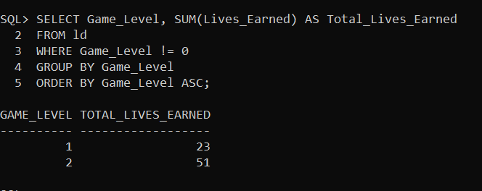

Q7) Find Top 3 score based on each dev_id and Rank them in increasing order using Row_Number. Display difficulty as well.

Ans:

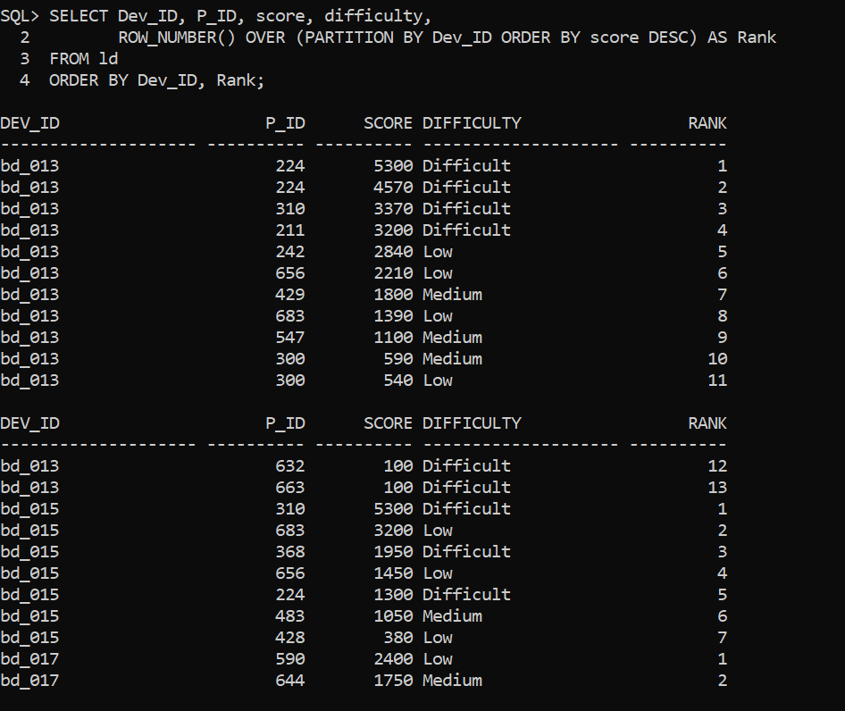

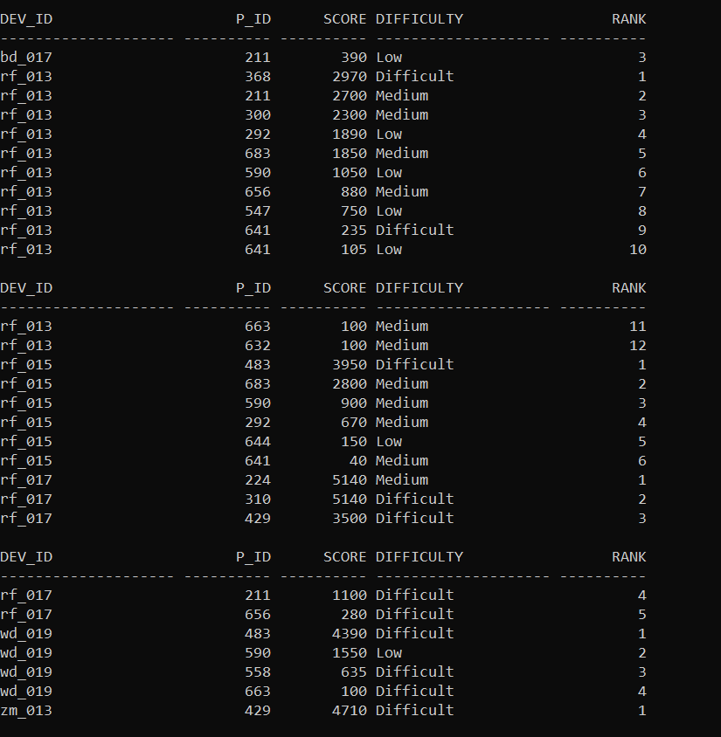

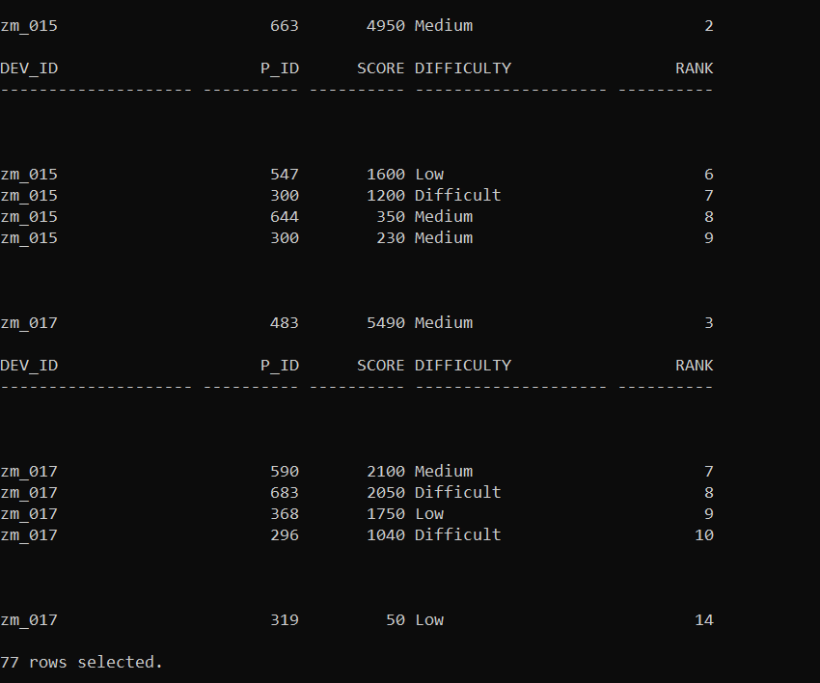

Q8) Find first_login datetime for each device id

Ans:

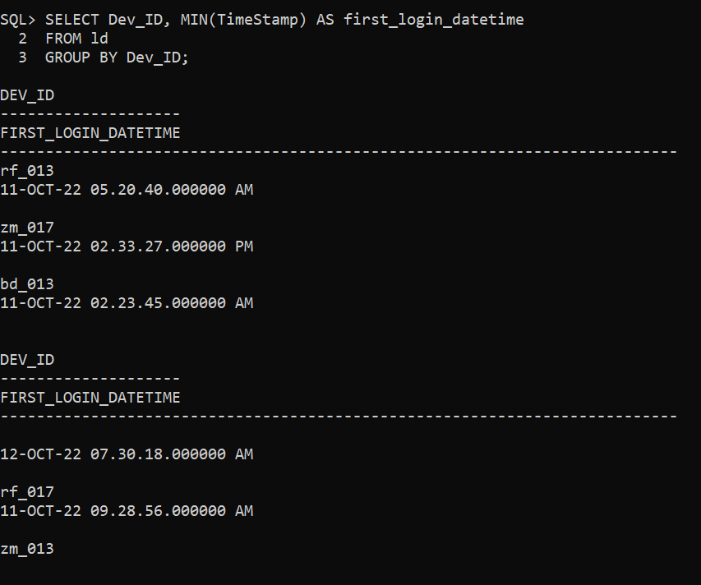

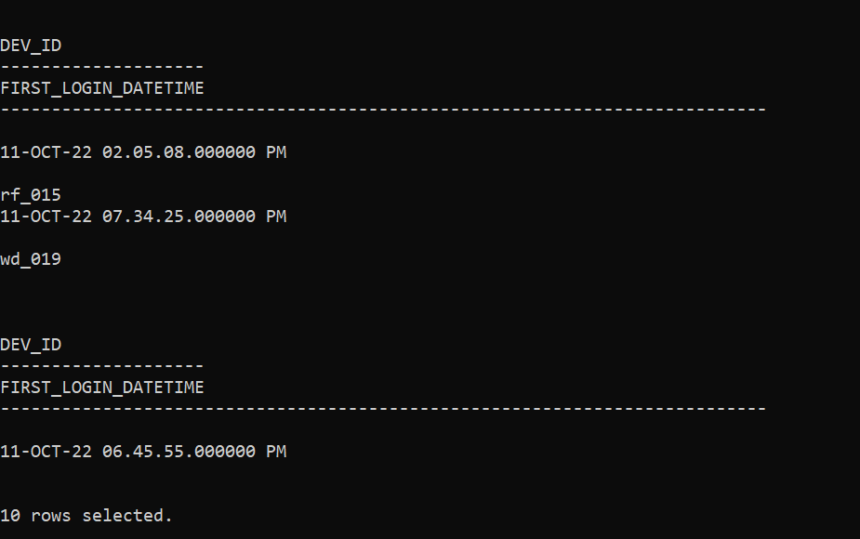

Q9) Find Top 5 score based on each difficulty level and Rank them in increasing order using Rank. Display dev_id as well.

Ans:

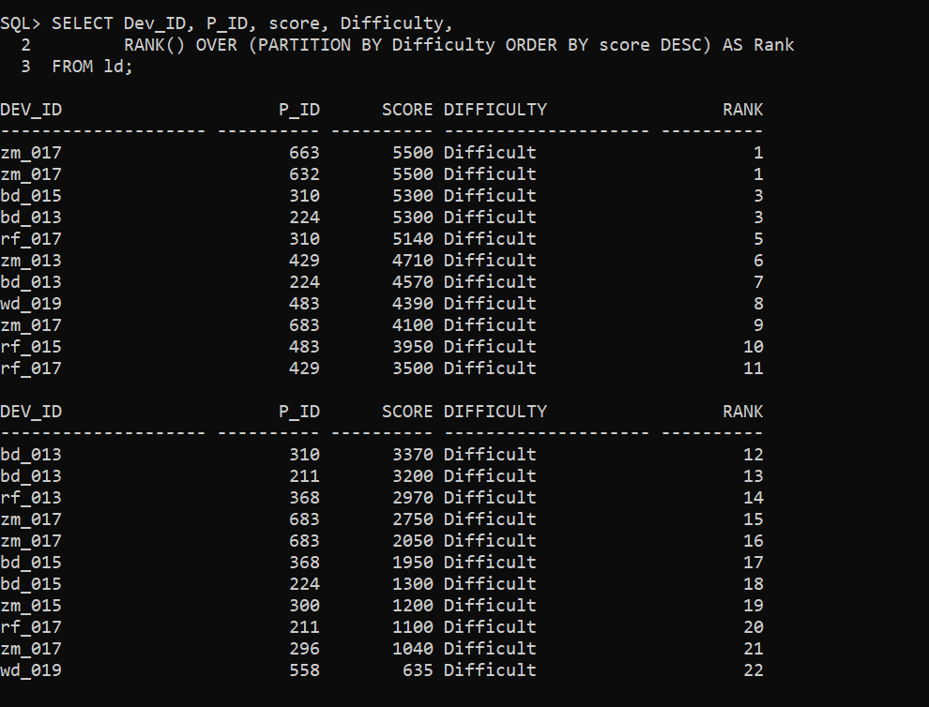

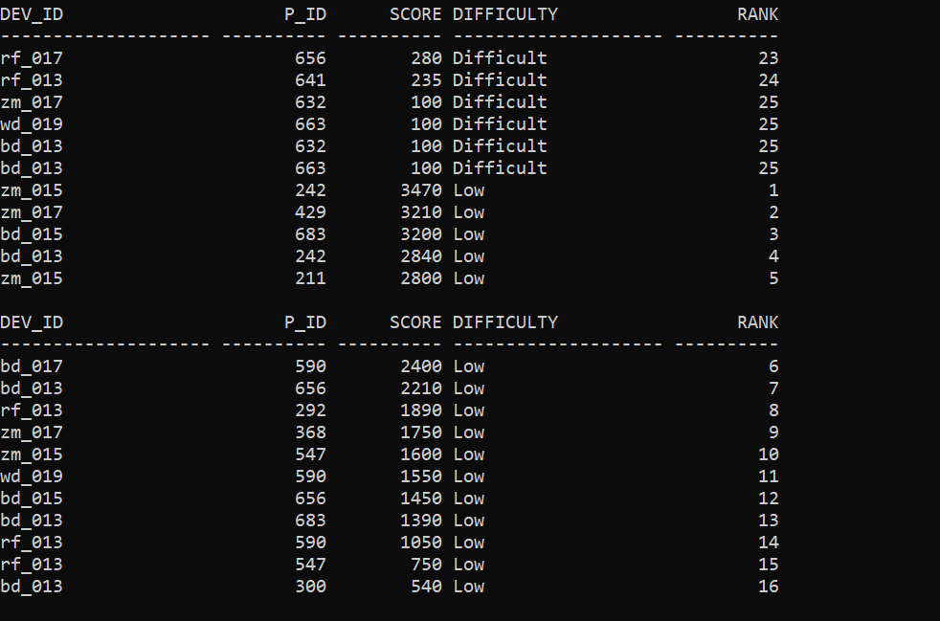

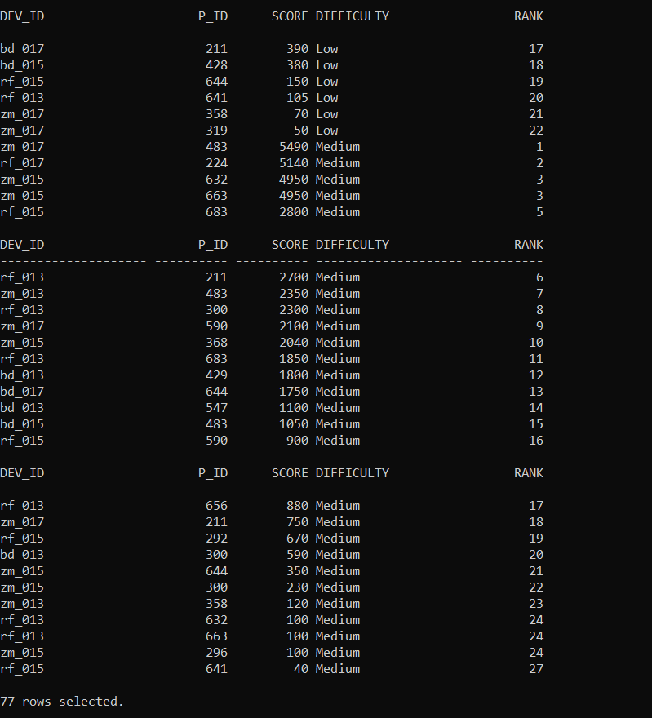

Q10) Find the device ID that is first logged in(based on start_datetime)for each player(p_id). Output should contain player id,device id and first login datetime.

Ans:

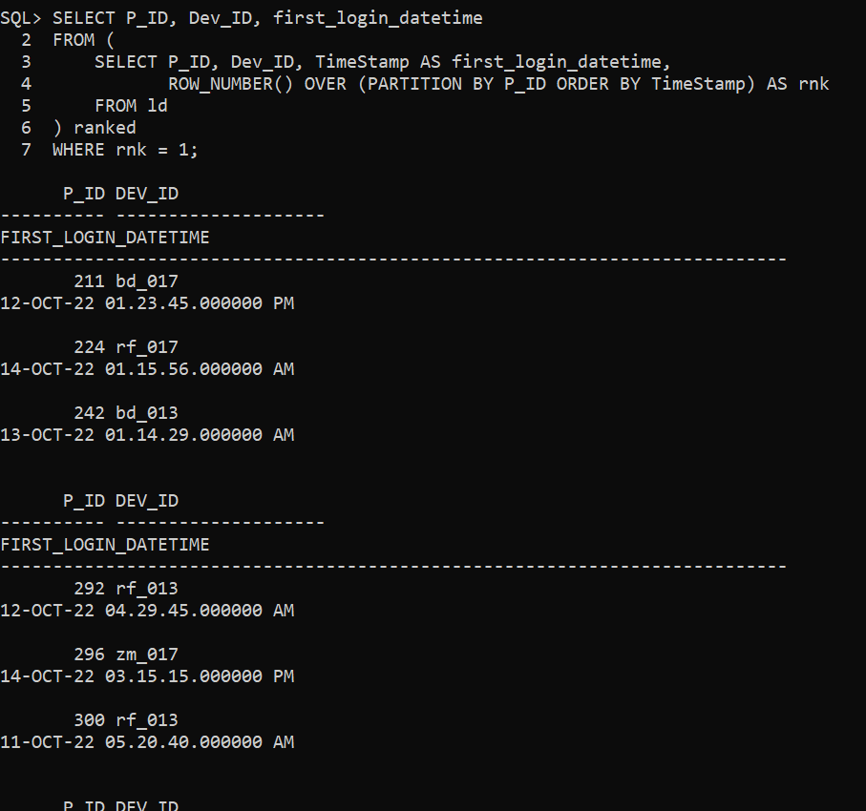

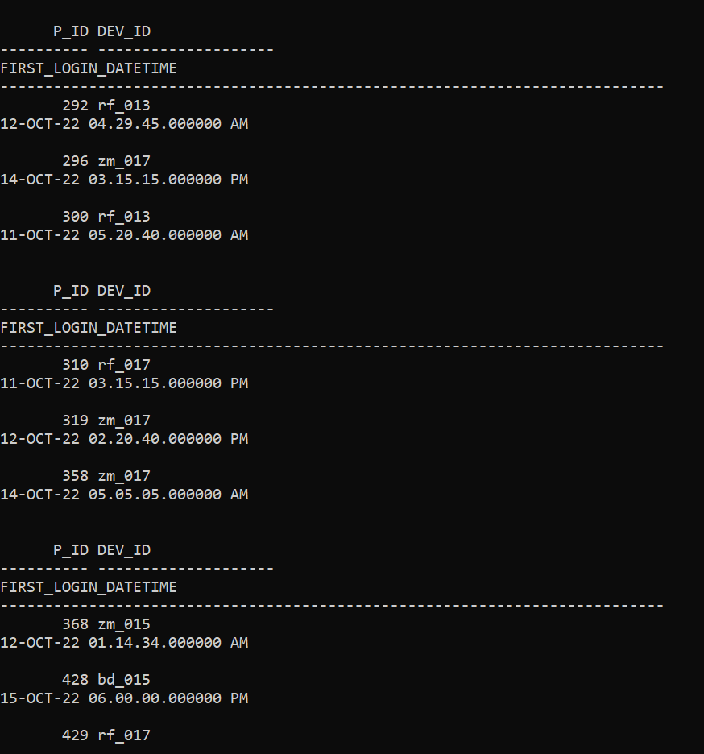

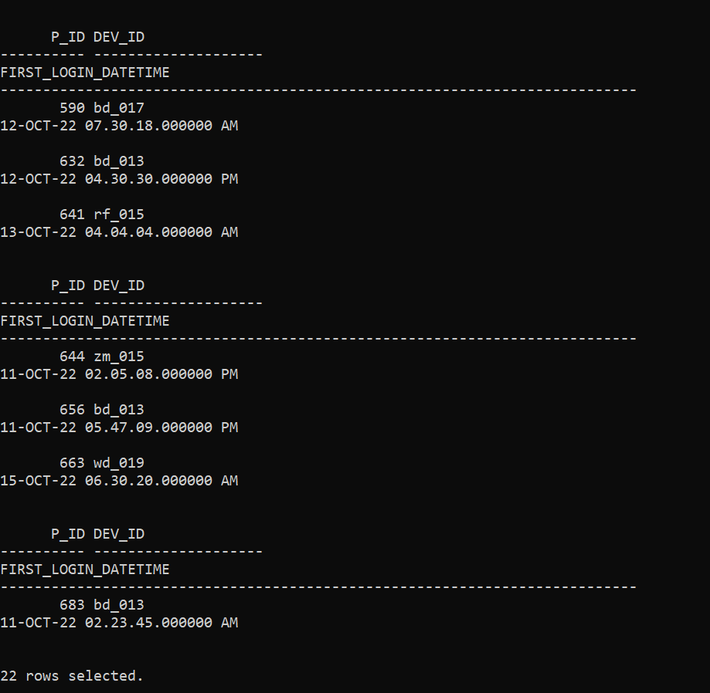

Q11) For each player and date, how many kill_count played so far by the player. That is, the total number of games played -- by the player until that date.

a) window function

Ans:

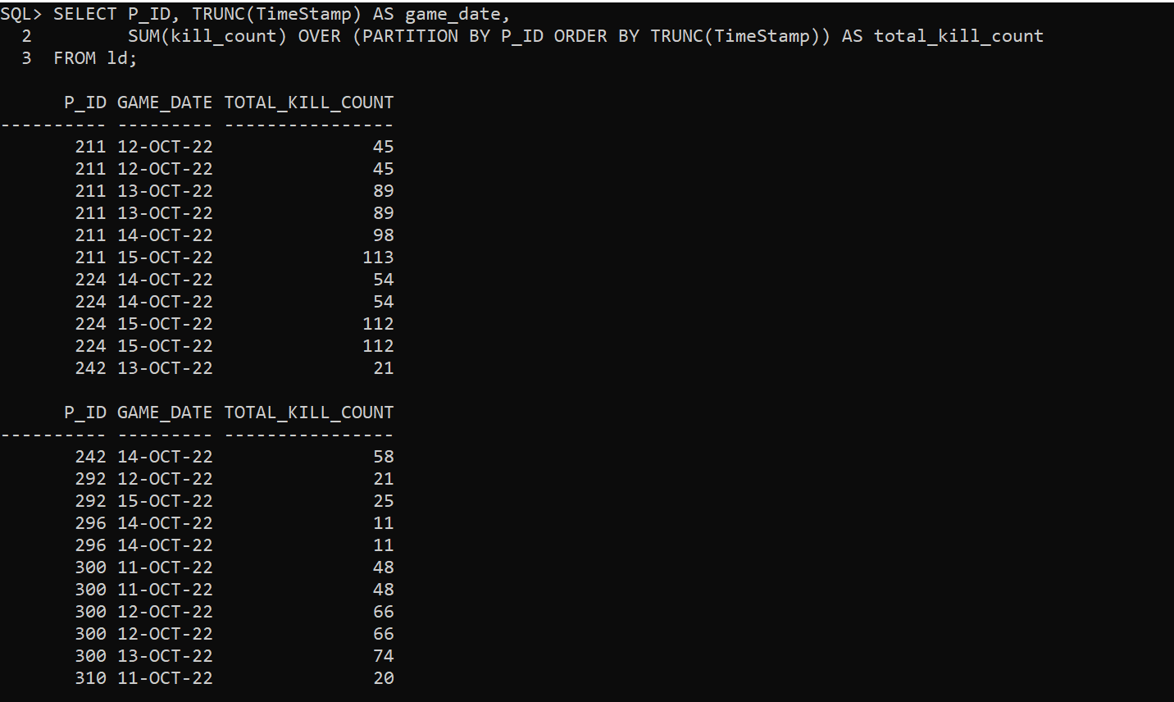

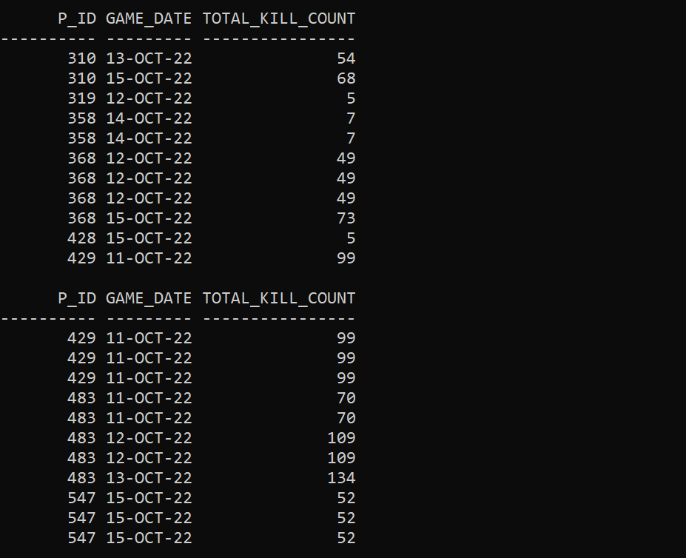

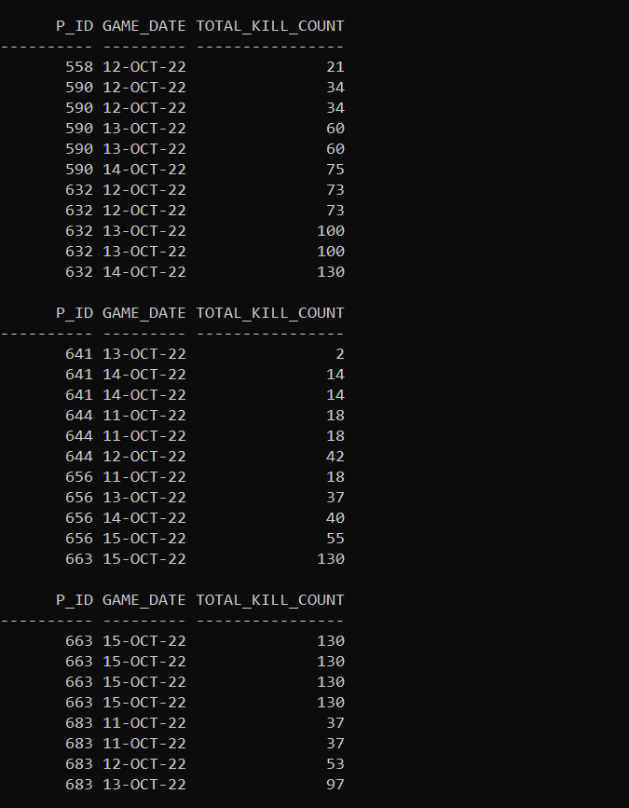



b) without window function

Ans:

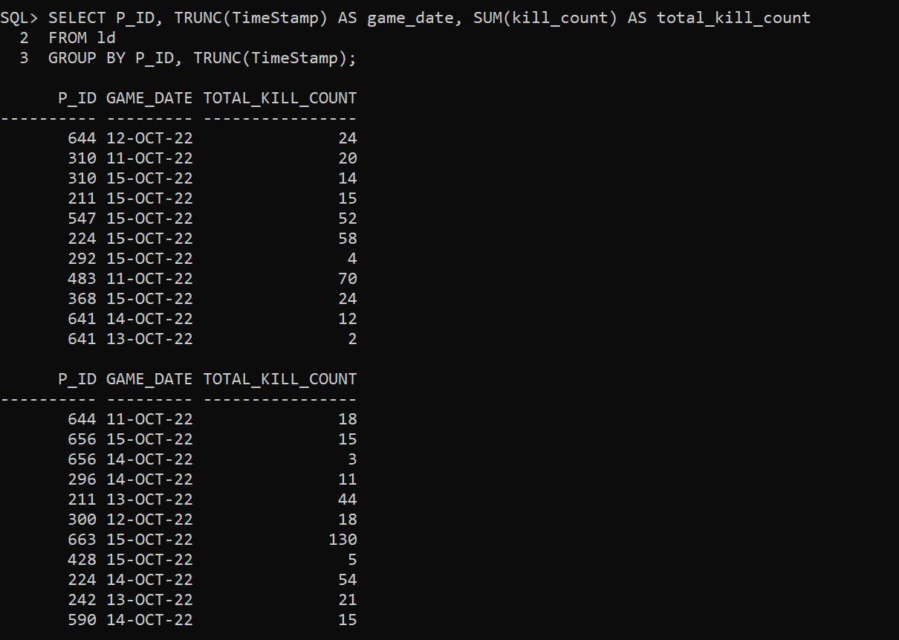

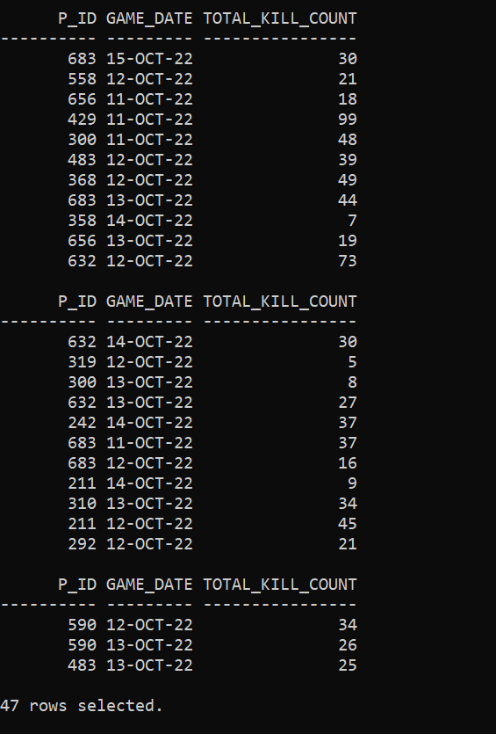

Q12) Find the cumulative sum of stages crossed over a start_datetime

ANS:

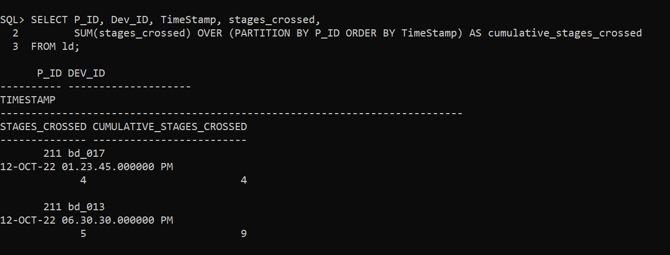

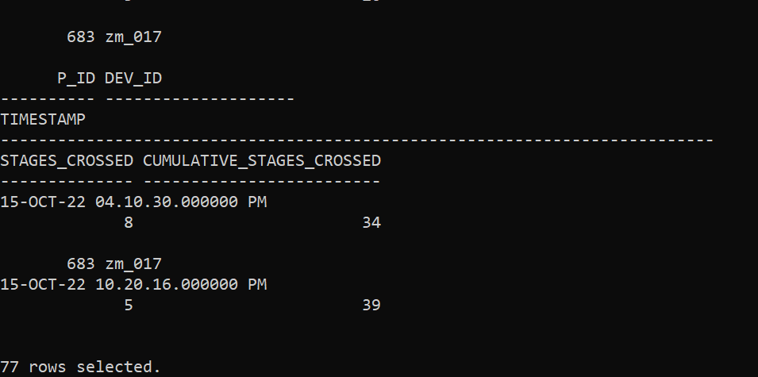

Q13) Find the cumulative sum of an stages crossed over a start_datetime for each player id but exclude the most recent start_datetime

ANS:

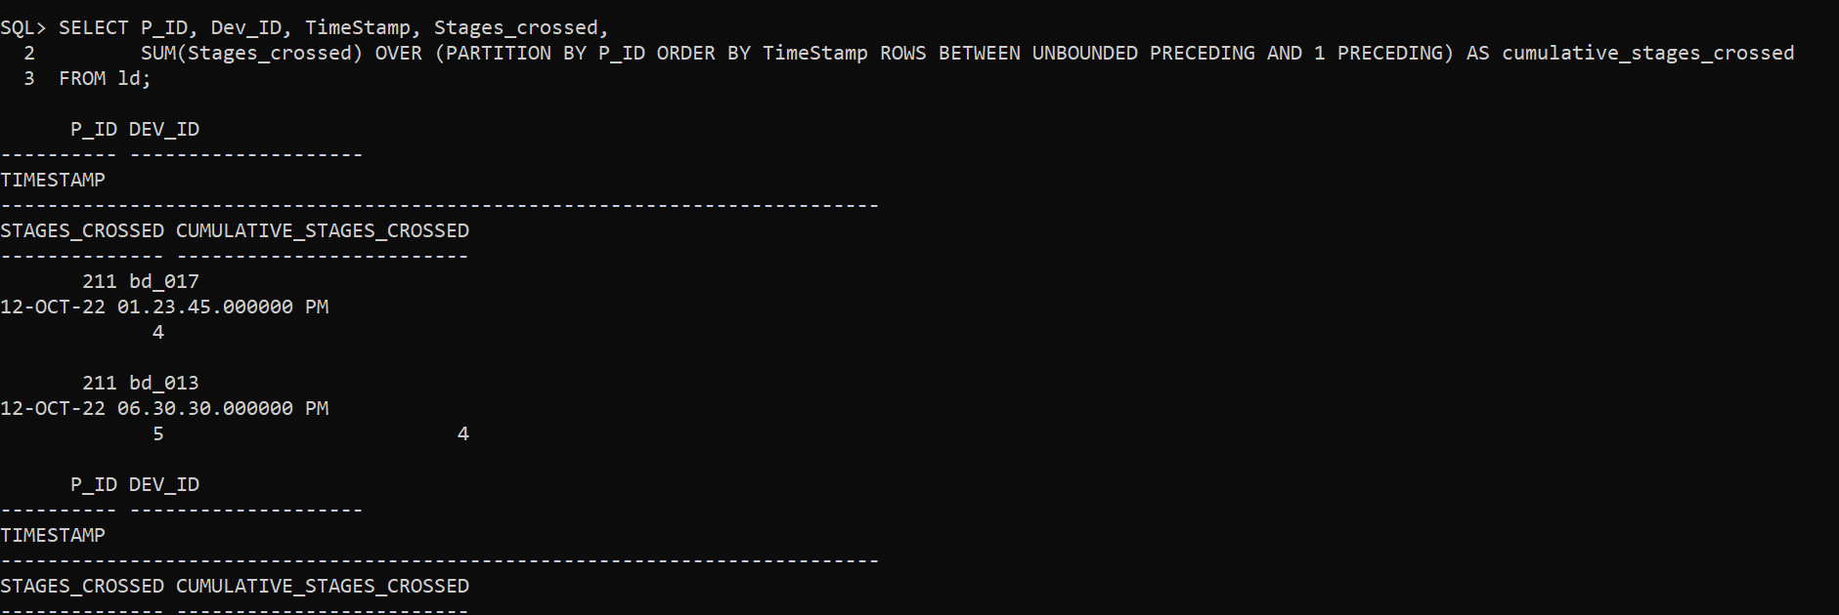

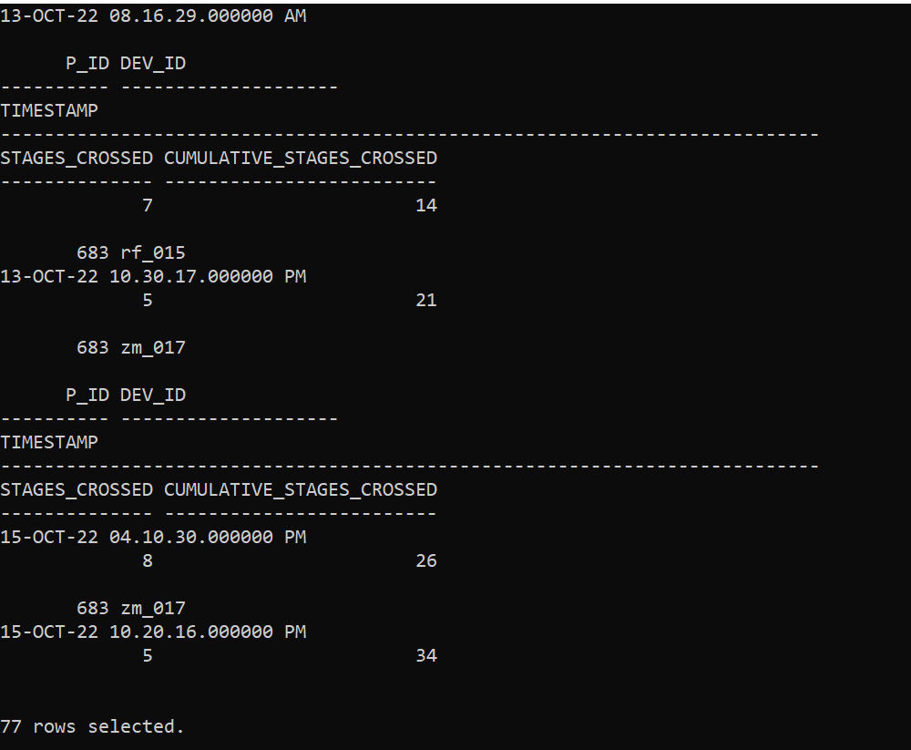

Q14) Extract top 3 highest sum of score for each device id and the corresponding player_id

Ans:

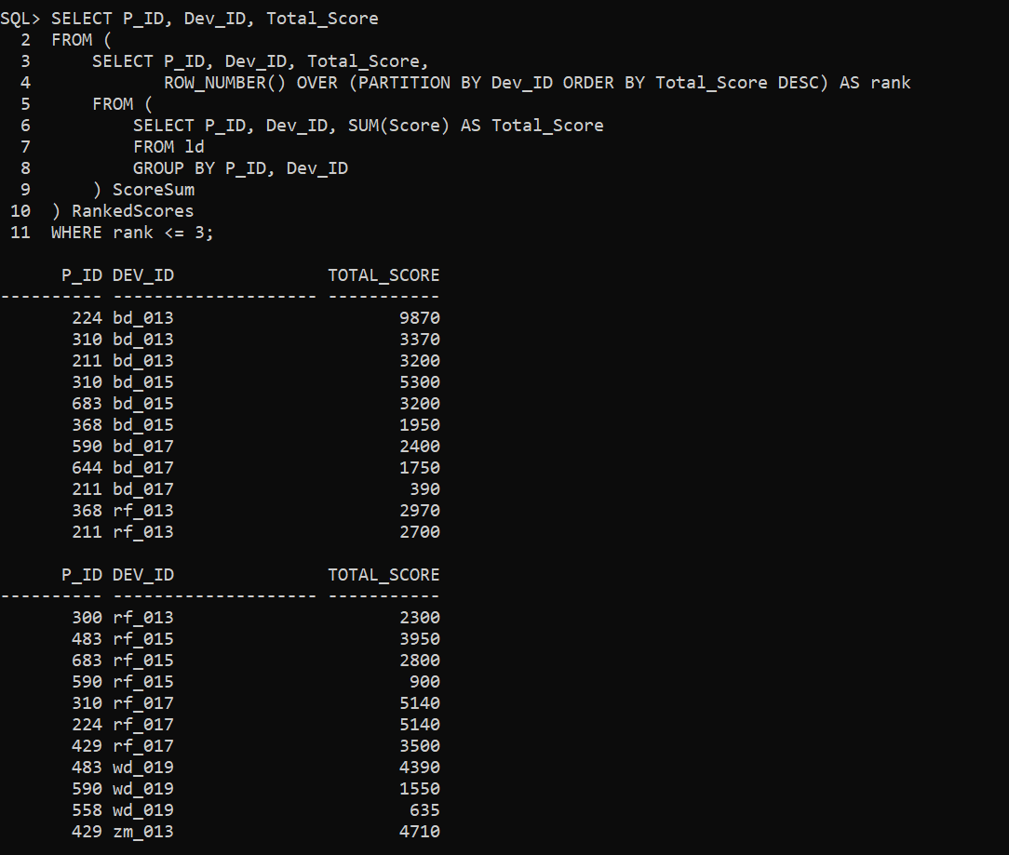

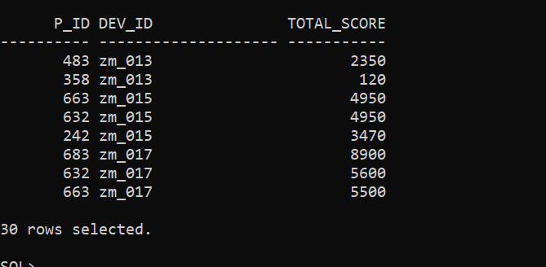

Q15) Find players who scored more than 50% of the avg score scored by sum of scores for each player_id

Ans:

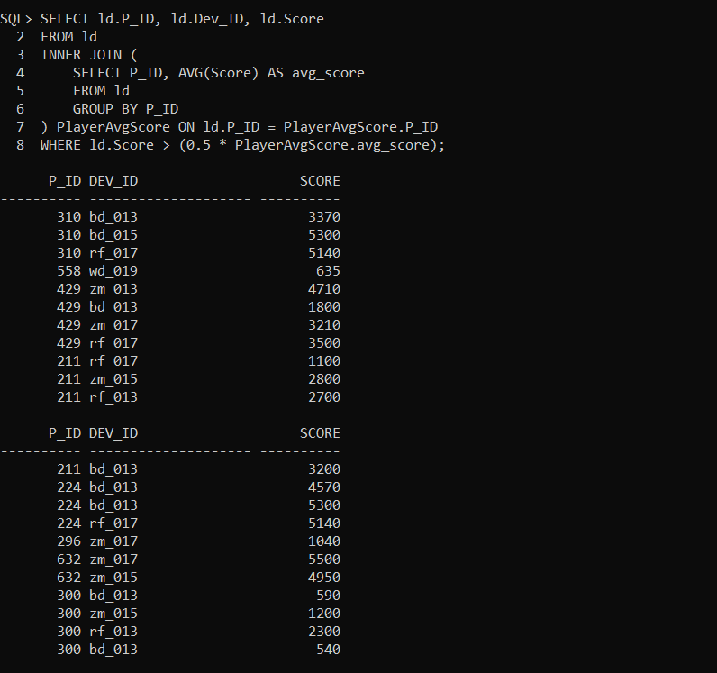

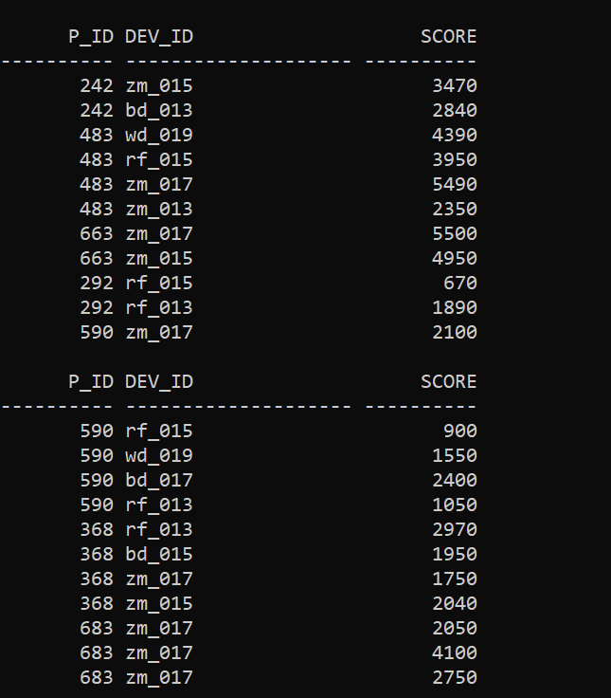

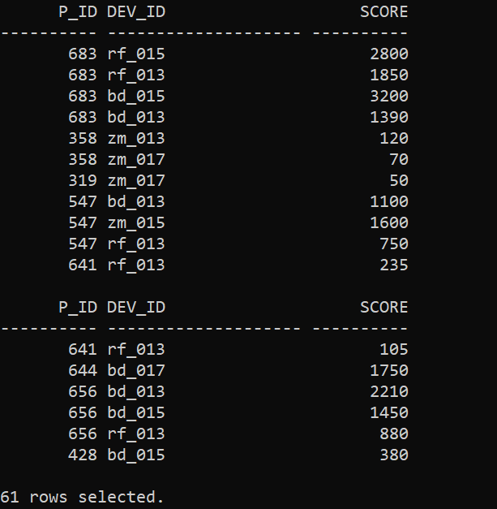

Q16) Create a stored procedure to find top n headshots_count based on each dev_id and Rank them in increasing orderusing Row_Number. Display difficulty as well.

Ans:

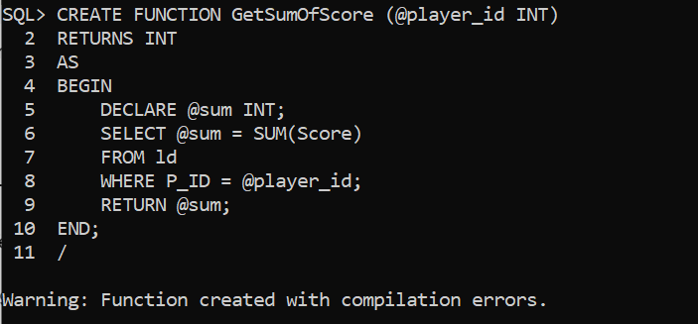

Q17) Create a function to return sum of Score for a given player_id.

Ans:

